Name: Brian Guadron
Date: 11/01/2026
Module 2.2 Assignment – Documented Debugging - Skill Check code

Created a break point on the sum_and_print(5,10) and returned_result = sum_and_return(15,20) functions and started the debugging process.
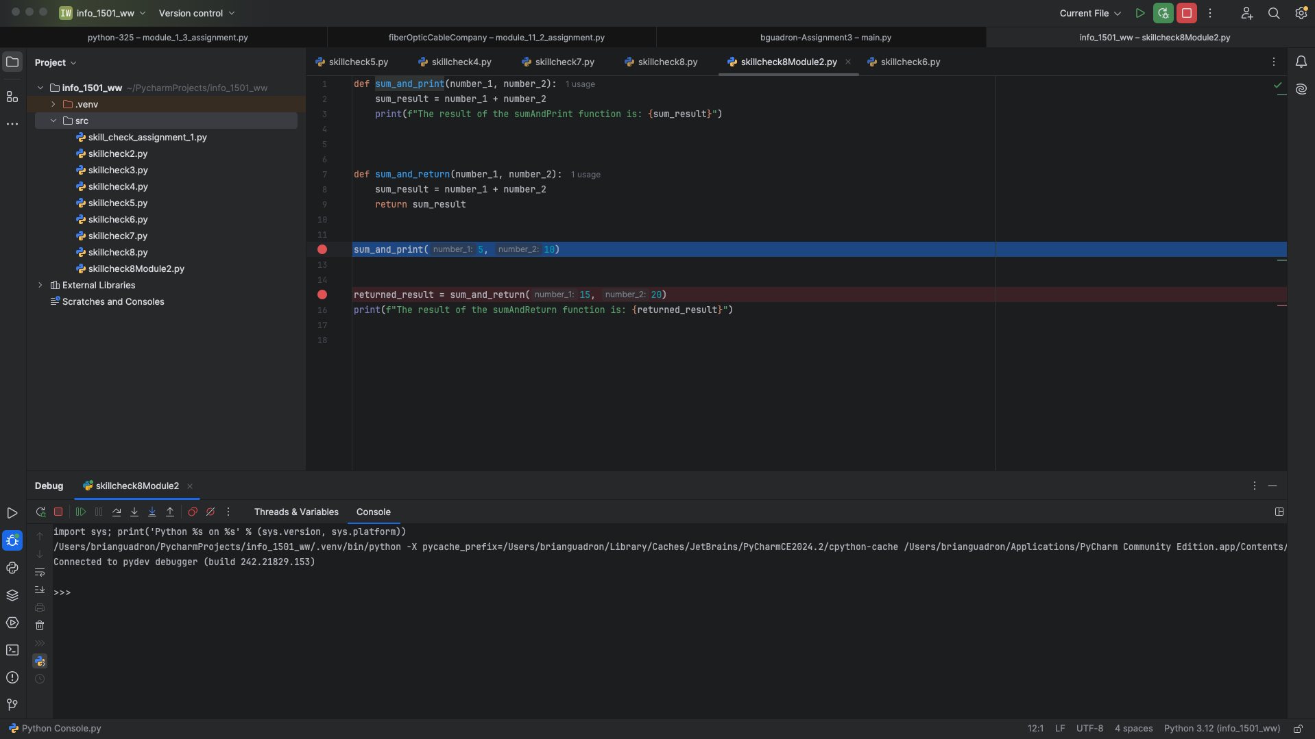

Stepped into the sum_and_print(5,10) function, which takes me to line 2, where the sum_result value is calculated.

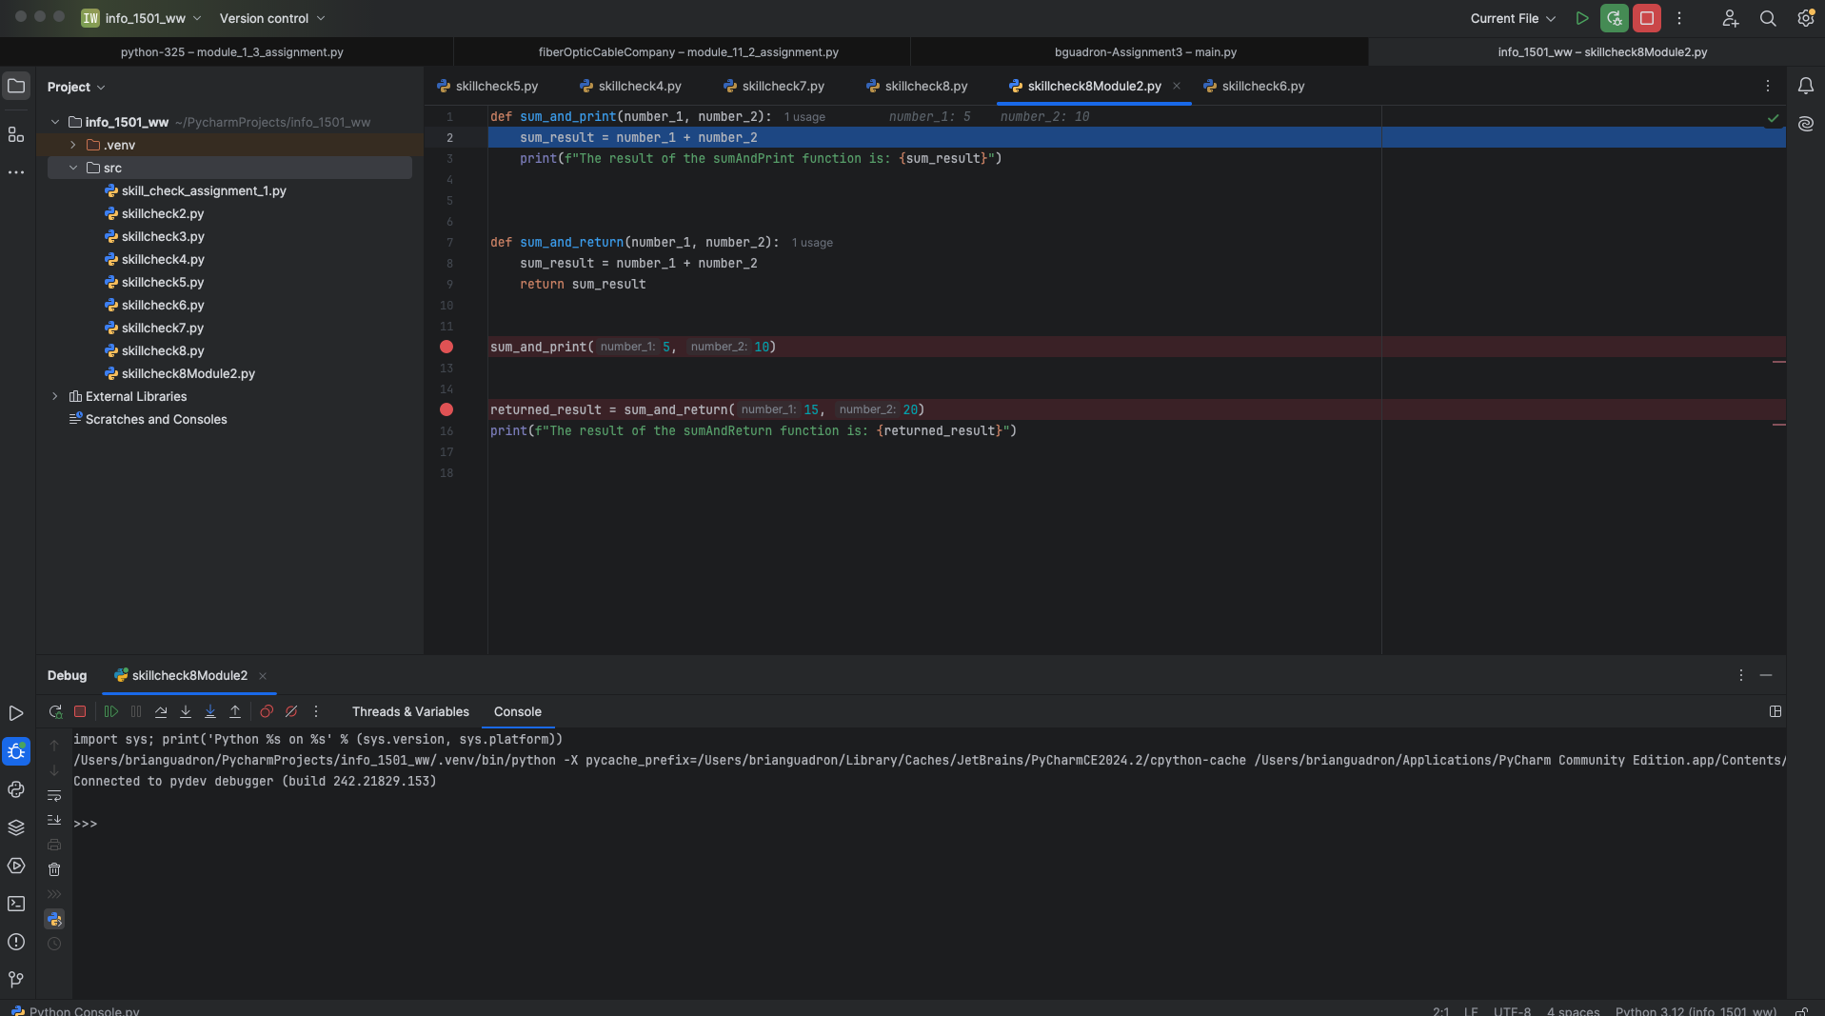

Stepped over to line 3, where calculation of sum_result was completed, and the value is visible in the Threads & Variables tab.
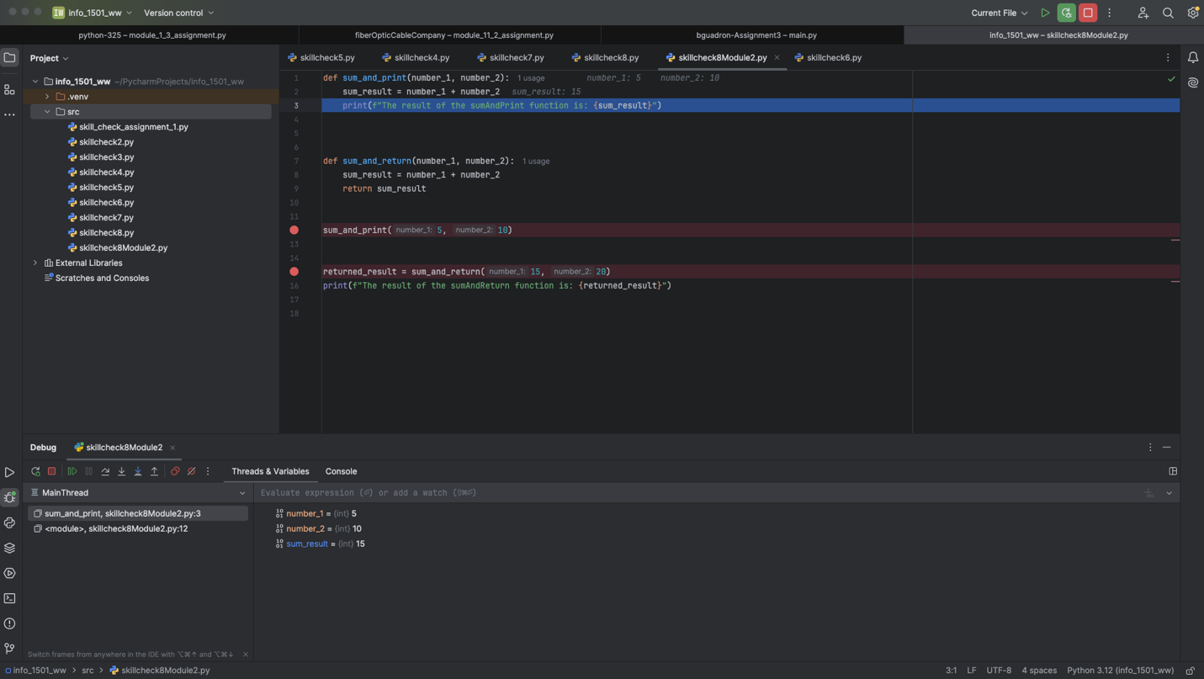

Stepped over one more time, which takes me back to line 12. The print statement on line 3 was executed, displaying the calculated sum_and_print value 15.
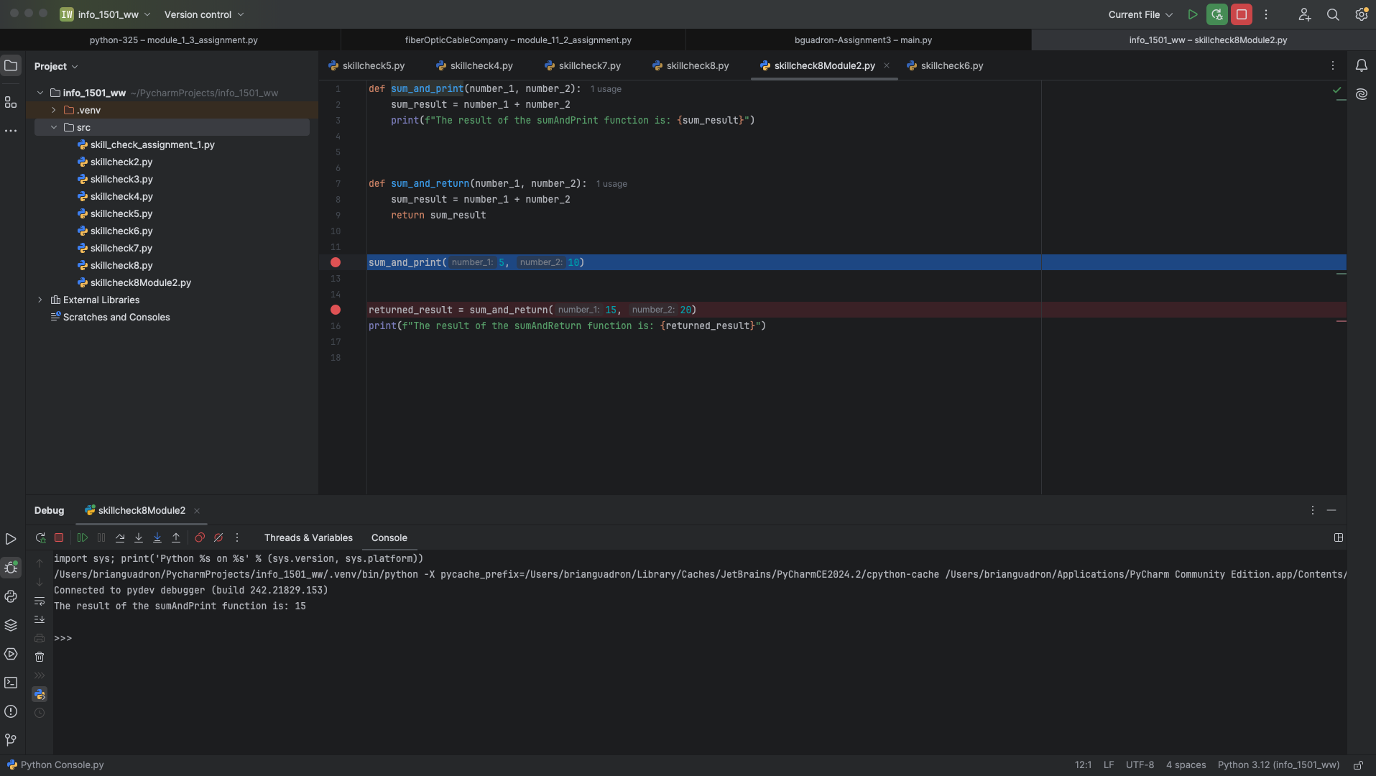

Stepped over to the next breakpoint in line 15.
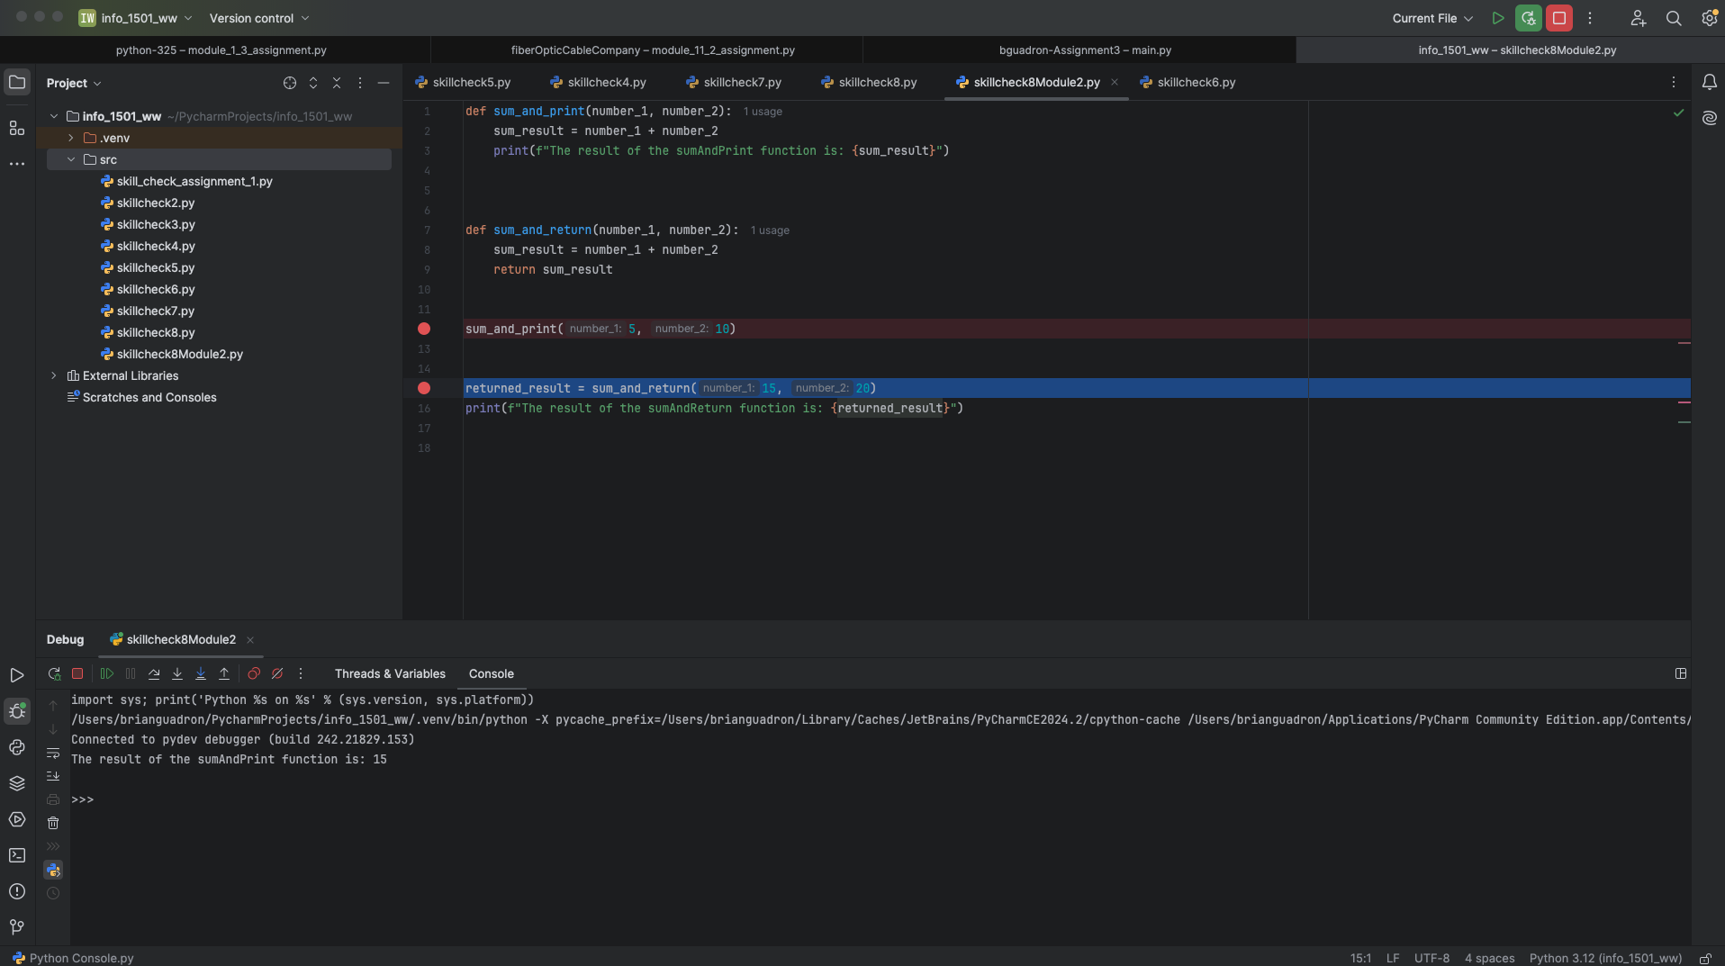

Stepped into sum_and_return(15, 20) function, which took me to line 8
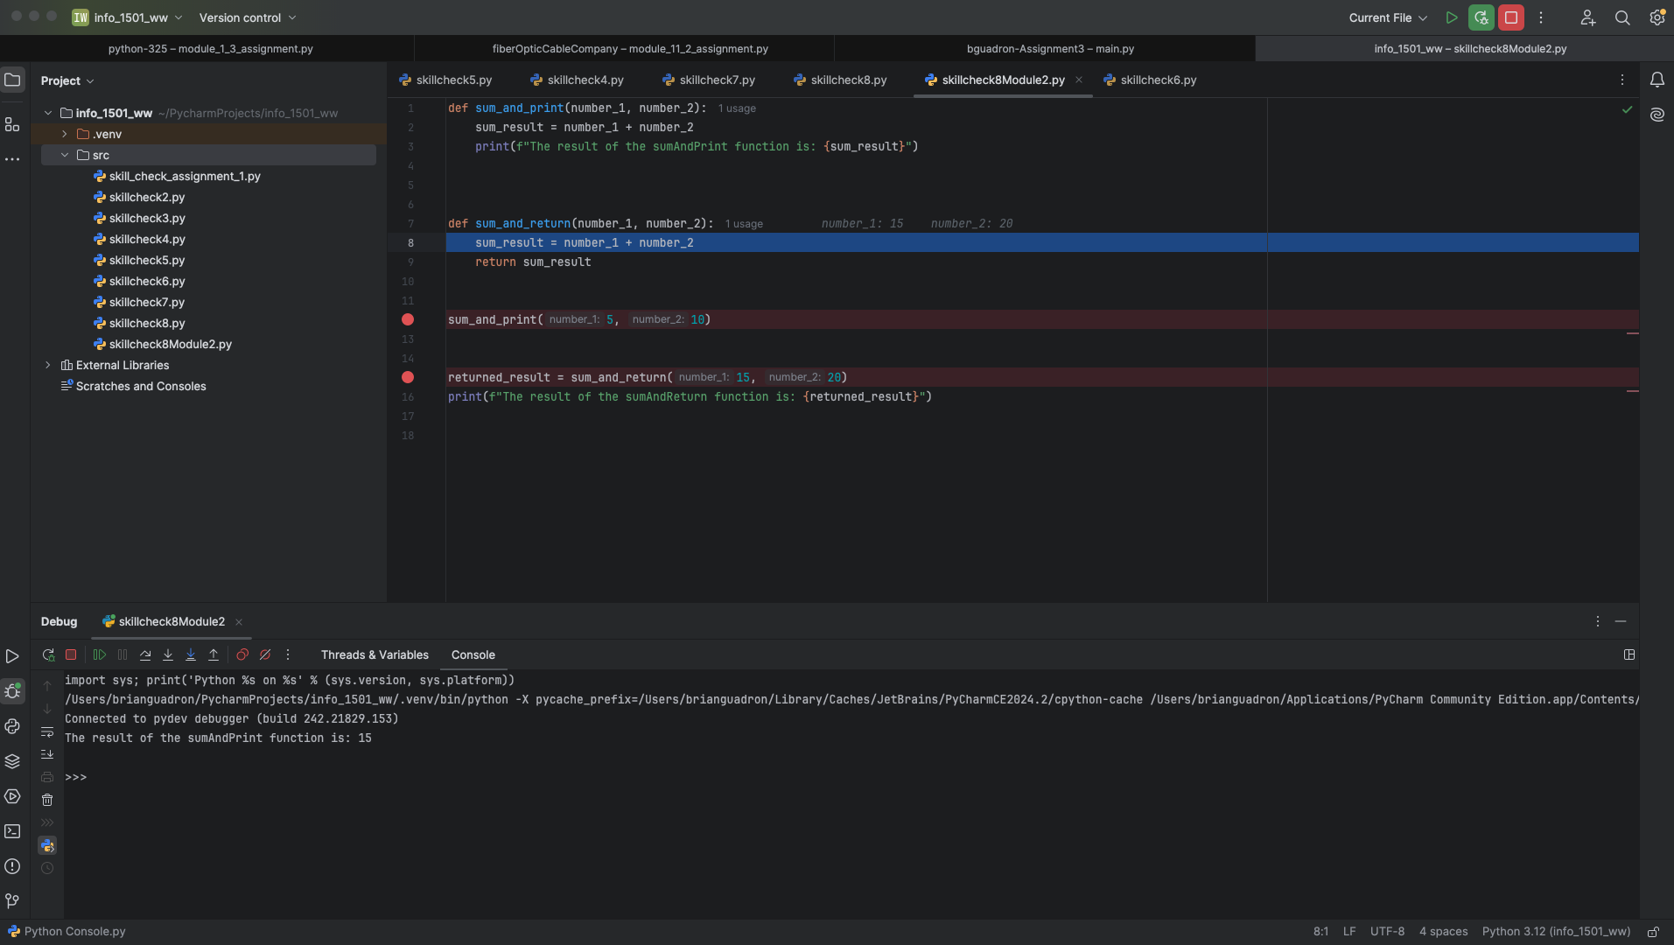

Stepped over to line 9, where the calculation of sum_result was completed, and the value is visible in the Threads & Variables tab.
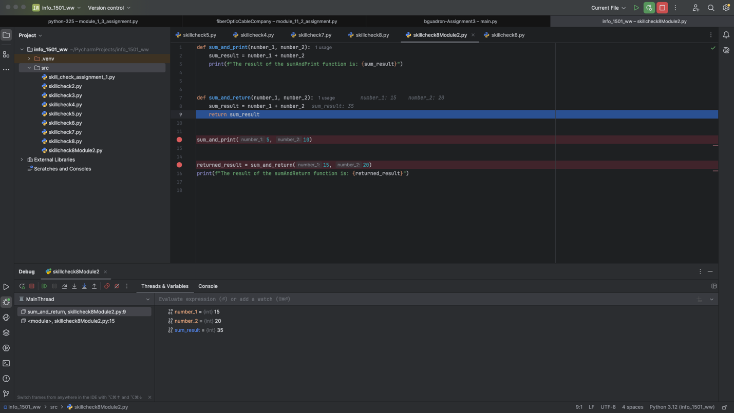

Stepped over one more time, which took me back to line 15.
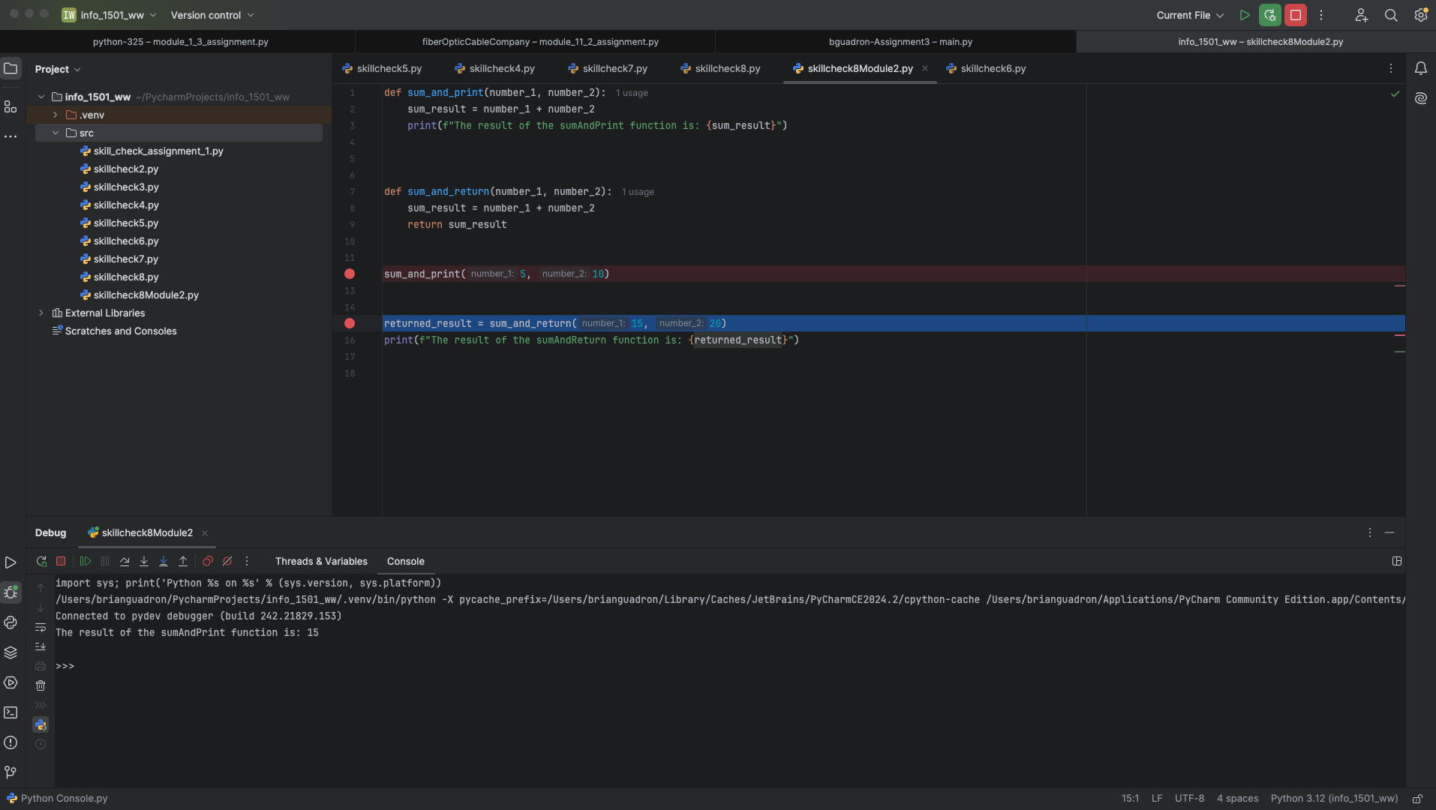
Stepped over one more time, which took me to the print statement on line 16
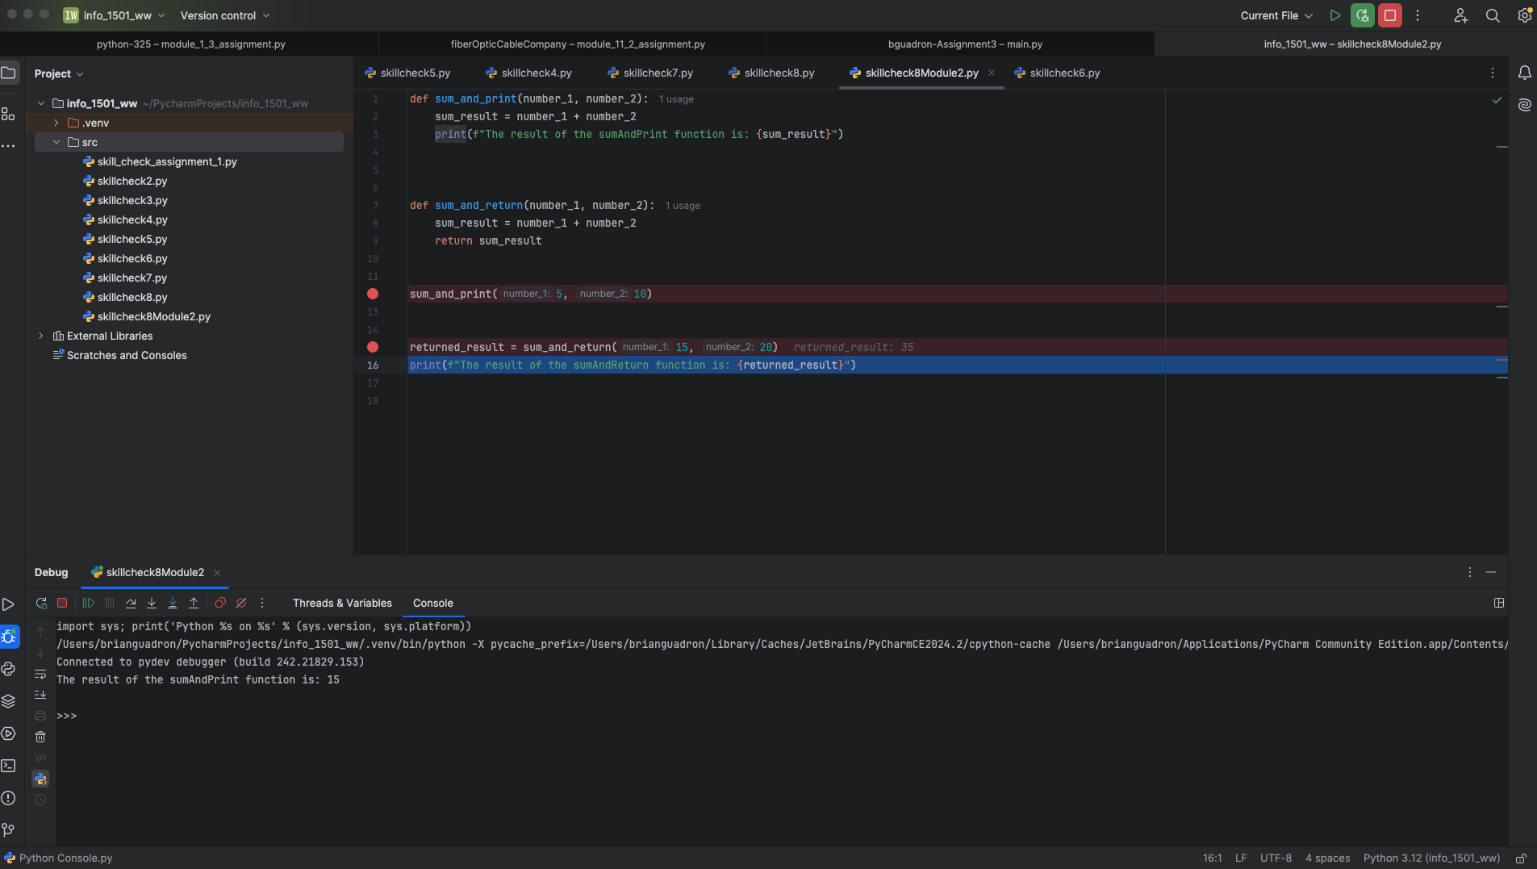

Stepping over one more time, executing the print statement in line 1. The output was displayed in the console, and the debugging process and code execution were completed.



